Curriculum Vita

Shereen Jawad Kadhim Al-Ali
Department of Pathological Analyses,
College of Sciences
University of Basrah, Basrah, Iraq
Mobile: 00 964 781 868 6820
Emails: shereenalali@yahoo.com
sjkalali2016@gmail.com
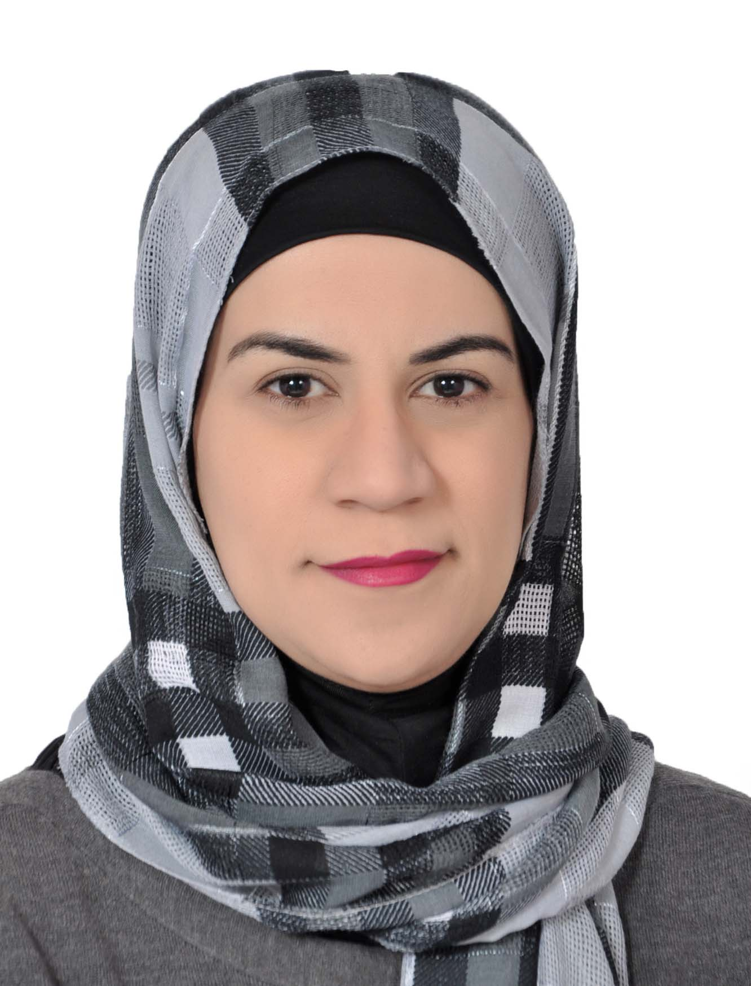
Address:

Date of Birth: 08/08/1978
Education:
PhD | 2016 | Faculty of Medical Sciences – Newcastle University – UK
MSc. | 2004 | College of Sciences – University of Basrah – Iraq
BSc. | 2000 | College of Sciences – University of Basrah – Iraq
High school | 1996 | Al-Khansa’a high school for girls – Iraq

Title of MSc. Thesis
Preparation of two Fasciola gigantica (Cobbold, 1856) antigens with the study of their antigenic efficacy in the serodiagnosis of the infection in experimental an natural hosts.
Title of PhD Thesis
Identification of whole-blood gene expression signature in primary Sjögren’s syndrome-associated lymphoma.

Employment:
27/03/2010 | Assistant professor in College of Sciences, University of Basrah, Iraq
27/03/2007 | lecturer in College of Sciences, University of Basrah, Iraq
29/02/2004 | Assistant lecturer in College of Sciences, University of Basrah, Iraq
07/09/2002 | Assistant researcher in College of Sciences, University of Basrah, Iraq

Teaching and work experience:
Undergraduate studies
Principles of immunology | Dep. of Biology | 3rd year – College of Sciences, Uni. of Basrah, Iraq
Serology | Dep. of Biology | 4th year – College of Sciences, Uni. of Basrah, Iraq
Parasitology | Dep. of Biology | 3rd year – College of Sciences, Uni. of Basrah, Iraq
Physiology of parasites | Dep. of Biology | 3rd year – College of Sciences, Uni. of Basrah, Iraq
General Biology | Dep. of Biology | 1st year – College of Sciences, Uni. of Basrah, Iraq
Fundamental Lab. skills | Dep. of Path. Ana. | 1st year – College of Sciences, Uni. of Basrah, Iraq

Postgraduate studies:
Advanced immunology | Dep. of Biology | PhD study – College of Sciences, Uni. of Basrah, Iraq
Clinical immunology | Dep. of Biology | MSc. study – College of Sciences, Uni. of Basrah, Iraq

- Worked as a member of the examination committee in the department of Biology, College of Sciences, University of Basrah, Iraq from 2004-2007.
- Worked as a member of the postgraduate committee in the department of Biology, College of Sciences, University of Basrah, Iraq from 2007-2010.
- Worked as a member of the examination committee in the department of Biology, College of Sciences, University of Basrah, Iraq from 2017-2018.
- Worked as a chief of the examination committee in the department of Pathological Analyses, College of Sciences, University of Basrah, Iraq from 2004-2007.

Postgraduate students (supervision):
- Alaa Abdul Hussain Saleh – PhD student
- Ieman Muafeq – MSc student

Research interest and publications:
Research interest:
My current interest is molecular Immunology in general and to investigate the immunological and the molecular aspects of autoimmune diseases such as primary Sjögren’s syndrome, rheumatoid arthritis etc. in addition to malignancies.
Publications:
- Al-Ali, S. J. k. 2007. Effect of Lidocaine Diclofenac and their mixture on some blood parameters in experimental mice. Bas J.Vet.Res., 6(1):29-37.
- Al- Toama M. A., Al-Nazal, H. A. N. and Al-Ali, S. J. k. 2007. A Histological study of the effect of Nandrolone decanoat on testes of F. gigantica infected rabbits treated and not treated with Rafoxanide. J.Bas. Res.(Sci.).33(2):22-29.
- Al-Ali, S. J. K. and Abdula, A. F. 2007. Effect of acute and chronic lead nitrate exposure on some physiological parameters in experimental mice. Bas J.Vet.Res., 6(2):78-87.
- Al-Emarah, G. Y., Al-Ali, S. J. K. and Azziz, S. A. 2008. Pervelence of Parascaris equorum infections in Karmat Ali in Basrah. Bas J.Vet.Res.7(1):34-38.
- Al-Emarah, G. Y., Al-Ali, S. J. K. and Azziz, S. A. 2009. Atlas of Parasites: Part I Human & Horses. Al-Salam printing, Basrah, Iraq. pp.1-47.
- Al-Emarah, G. Y., Al-Ali, S. J. K. and Ahmed, M. A. 2009. Natural date vinegar as a natural dye in staining and preservation of some tapeworm specimens and other parasite's eggs. Al-Qadisiya J.Vet.Med.Sci. 8(1):25-30.
- Atwan, Z., Mahdy, M. A. and Al-Ali, S. 2010. Evaluation of complement components C3 and C4 in serum of patient with neoplastic diseases. J.Thi-Qar Sci. 2(3):3-7.
- Al-Ali, S. 2010. Estimation of Immunoglobulins and complement component C3 and C4 in some patients with Hodgkin and Non-Hodgkin Lymphoma in Basrah Governorate. J.Thi-Qar Sci. 2(3):48-56.
- James, K., Al-Ali, S., Tarn, J., Cockell, S. J., Gillespie, C. S., Hindmarsh, V., Locke, J., Mitchell, S., Lendrem, D., Bowman, S., Price, E., Pease, C. T., Emery, P., Lanyon, P., Hunter, J. A., Gupta, M., Bombardieri, M., Sutcliffe, N., Pitzalis, C., Mclaren, J., Cooper, A., Regan, M., Giles, I., Isenberg, D., Saravanan, V., Coady, D., Dasgupta, B., Mchugh, N., Young-min, S., Moots, R., Gendi, N., Akil, M., Griffiths, B., Wipat, A., Newton, J., Jones, D. E., Isaacs, J., Hallinan, J. & Ng, W. F. 2015. A Transcriptional Signature of Fatigue Derived from Patients with Primary Sjogren's Syndrome. PLoS One, 10 (12), e0143970.
- Schoeman, E. M., Van der westhuizen, F. H., Erasmus, E., Van dyk, E., Knowles, C. V., Al-Ali, S., Ng, W. F., Taylor, R. W., Newton, J. L. & Elson, J. L. 2017. clinically proven mtdna mutations are not common in those with chronic fatigue syndrome. bmc med genet, 18, 29.
- BODEWES, I. L. A., AL-ALI, S., VAN HELDEN-MEEUWSEN, C. G., MARIA, N. I., TARN, J., LENDREM, D. W., SCHREURS, M. W. J., STEENWIJK, E. C., VAN DAELE, P. L. A., BOTH, T., BOWMAN, S. J., GRIFFITHS, B., NG, W. F. & VERSNEL, M. A. 2018. Systemic interferon type I and type II signatures in primary Sjogren's syndrome reveal differences in biological disease activity. Rheumatology (Oxford).

Conferences and workshops:
Conferences:
Poster presentations:
- Al-Ali S, Cockell S, Tarn J, James K, Young D, UKPSSR study group, Griffiths B, Bowman S and Ng WF. 2013. “Effects of globin mRNA on the whole blood gene expression signature of primary Sjögren's syndrome”. The 12th international Sjögren’s syndrome symposium ( New Era on Sjögren's Syndrome ), Kyoto, Japan, a young travel award winning abstract.
- Al-Ali S, Skelton A, Cockell S, James K, Tarn J , Young D, UKPSSR study group, Griffiths B, Bowman S and Ng WF. 2015. “Identification of whole blood gene expression signature of primary Sjögren's syndrome associated lymphoma”. The 13th International Symposium on Sjögren's Syndrome (ISSS), Bergen, Norway, Scandinavian Journal of Immunology, 81(5), 273.
- Al-Ali S, Skelton A, Cockell S, James K, Tarn J , Young D, UKPSSR study group, Griffiths B, Bowman S and Ng WF. 2016. “Whole blood transcriptomic signature of primary Sjögren’s syndrome-associated lymphoma”. BATTS, Oklahoma, U.S.
- Bodewes, I., AL-Ali, S., van Helden, C., Maria, N., Tarn, J., Lendrem, D., Schreurs, M., Steenwijk, E., van Daele, P. & Both, T. 2017. OP0097 Systemic ifn type i and type ii signatures in primary Sjogren’s syndrome reveal differences in disease severity. BMJ Publishing Group Ltd. EULAR, Madrid, Spain.
- AL-Ali, S., Skelton, A., Cockell, S., Tarn, J., James, K., Bowman, S., Griffiths, B., Young, D. & NG, W. 2017. THU0242 Biological pathway analysis in primary sjÖgren9s syndrome associated lymphoma. BMJ Publishing Group Ltd. EULAR, Madrid, Spain.
Oral presentations:
- Effect of Cryptococcus neoformans on some blood parameters and GOT and GPT levels in Experimental mice 25-26/04/2007. The 3rd International conference for Microbiology and Biotechnology, College of Education, University of Basrah, Iraq.
- The effect of the biological active compound 2,2-diamino-2,5 di(4-hydroxyphenyl)-4-oxo-5-thiouryl-(1,2,4) Oxadizolidine (Oxa) on some blood parameters in experimental mice. 22-23/10/2008. The First International conference of Veterinary medicine, college of veterinary medicine, University of Basrah, Iraq
- Al-Ali S, Skelton A, Cockell S, James K, Tarn J , Young D, UKPSSR study group, Griffiths B, Bowman S and Ng WF. 2014. “Identification of whole blood gene expression signature in primary Sjögren's syndrome-associated lymphoma”. Oral presentation at the ACR/ARHP Annual meeting (American College of Rheumatology) in Boston, USA. 2014 ACR/ARHP Annual Meeting Abstract Supplement, Arthritis & Rheumatology, 66 (S10), S1-S1402.
- Al-Ali S, Skelton A, Cockell S, James K, Tarn J , Young D, UKPSSR study group, Griffiths B, Bowman S and Ng WF. 2014. “Identification of whole blood gene expression signature in primary Sjögren's syndrome-associated lymphoma”. Oral presentation at The Annual Northern and Yorkshire Rheumatology Meeting at York, UK.
- Al-Ali S, Skelton A, Cockell S, James K, Tarn J , Young D, UKPSSR study group, Griffiths B, Bowman S and Ng WF. 2016. “Whole blood transcriptomic signature of primary Sjögren’s syndrome-associated lymphoma”. Oral presentation at The Annual Northern and Yorkshire Rheumatology Meeting at York, UK.
- Al-Ali S, Skelton A, Cockell S, James K, Tarn J , Young D, UKPSSR study group, Griffiths B, Bowman S and Ng WF. 2019. “Whole blood transcriptomic signature of primary Sjögren’s syndrome-associated lymphoma”. Oral presentation at 1st symposium on cancer research and database development in Kurdistan. Erbil, Iraq.

Workshops and scientific activities attendance :
- Environmental health in post -war Iraq- risk factors, exposure assessment, epidemiology and community medicine”. 7-16/02/2005, Amman, Jordan, organized by University of Greifswald and University of Bremen, Germany.
- Cancer registration and environmental health risk assessment of the population – methods, implementation and analysis. 19-28/02/2006. University of Greifswald, Germany.
- The use of DNA fingerprint in the identification of missing person victims of mass fatalities. 11-15/04/ 2010. College of Sciences, University of Basrah, Iraq.
- Immunohistochemistry: it’s importance in diagnosis and research. 11-12/12/2016. College of Sciences, University of Basrah, Iraq.
- The use of Flowcytometry in laboratory and researches. 9-11/01/2017. College of Sciences, University of Basrah, Iraq.
- Real time PCR application. 28-30/03/2017. College of Sciences, University of Basrah, Iraq.
- DNA sequencing and bioinformatics. 19-20/3/2018. College of veterinary medicine, University of Basrah, Iraq.
- How to Give a Professional Presentation for International conferences? 27/3 and 3/4 2018. College of Sciences, University of Basrah, Iraq.
- How to design a poster 30/4/2018. College of Sciences, University of Basrah, Iraq.
- Real time PCR application. 30-31/12/2018. College of Sciences, University of Basrah, Iraq.
- Applications of GC/MS in pathological analyses. 22-23/4/2019. College of Sciences, University of Basrah, Iraq.
- 2nd IAMRS international conference. 22-23/3/2019. Basrah. Iraq.

